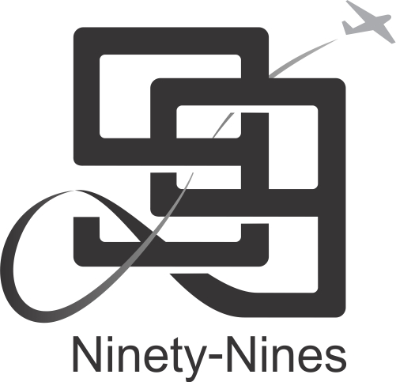

For Immediate Release

[Catchy Title Here (Bold, u/l case]

[City of Origin, State]

[Date of press release]

[(first paragraph) Grab their attention here. A strong introductory paragraph should cover who, what, when, where, why and how.

Follow with remaining paragraphs. Expound on the information provided in your introductory paragraph. Include quotes from key members or subject matter experts. The body of your press release should contain more than one paragraph. The final paragraph should restate and summarize the key points of your news release. Do your best to keep your release between 350-500 words.]

[Supplementary information on The 99s, the AEMSF, the AEBM and/or the Museum of Women Pilots, your Chapter, your Section, as appropriate to the article above]

For more information contact:
[your name,
your best phone number,
your email address]

# # # # # #

